National College of Ireland

HDSDEV_SEP23

2023/2024

Alexandru

23124091

[x23124091@student.ncirl.ie](mailto:x23124091@student.ncirl.ie)

**SoulJournal**

Technical Report



**National College of Ireland**

**Project Submission Sheet – 2022/2023**

Student Name: Alexandru Georgescu

Student ID: 23124091

Programme: Higher Diploma In Software Development (HDSDEV_SEP23)

Year: 1

Module: Project

Lecturer: Hamilton Niculescu

Submission Due Date: 10/08/2024

Project Title: **SoulJournal**

Word Count (excluding bibliography and appendices):

I hereby certify that the information contained in this (my submission) is information pertaining to research I conducted for this project. All information other than my own contribution will be fully referenced and listed in the relevant bibliography section at the rear of the project.

ALL internet material must be referenced in the references section. Students are encouraged to use the Harvard Referencing Standard supplied by the Library. To use other author's written or electronic work is illegal (plagiarism) and may result in disciplinary action. Students may be required to undergo a viva (oral examination) if there is suspicion about the validity of their submitted work.

|  |  |
| --- | --- |
| **Signature:** | Alexandru Georgescu |
| **Date:** | 10/08/2024 |

**Table of Contents**

Table of Figures 5

Glossary, Acronyms, Abbreviations and Definitions 6

Executive Summary 7

1 Introduction 8

1.1 Background 8

1.2 Aims 8

1.3 Technologies 9

1.4 Structure 12

2 System 14

2.1 Requirements 14

2.1.1 Functional requirements 14

2.1.2 Data requirements 31

2.1.3 User requirements 31

2.1.4 Environmental requirements 32

2.1.5 Usability requirements 34

2.2 Design and Architecture 35

2.3 Implementation 41

2.4 Testing 41

2.5 Graphical User Interface (GUI) Layout 41

2.6 Customer testing 42

2.7 Evaluation 42

3 Conclusions 44

4 Further development or research 45

5 References 46

6 Appendix 47

6.1 Project Proposal 47

6.2 Project Plan 47

6.3 Requirement Specification 47

6.4 Monthly Journal 47

6.5 Other Material Used 47

# Table of Figures

A table containing all the figure number, description and page

# Glossary, Acronyms, Abbreviations and Definitions

A table containing all the terms and acronyms used in the document.

# Executive Summary

**SoulJournal** addresses the challenge of maintaining mental well-being through regular journaling. Many individuals struggle to keep a consistent journaling habit due to lack of motivation, organization, and accessibility([TheHappyJournals](https://www.thehappyjournals.com/hard-to-stick-to-a-journaling-routine/)).

Souljournal is a web-based application designed to simplify and enhance the journaling experience by providing an intuitive and user-friendly platform.

The technical solution involves a React-based frontend integrated with a backend server that manages user authentication, journal entries, and feedback. The application leverages modern web technologies such as React Router for seamless navigation, Bootstrap for responsive design, and RESTful APIs for efficient data handling. Key features include user registration and login, creating and managing journal entries, receiving motivational quotes, and providing feedback.

The evaluation of **SoulJournal** was conducted through user testing and feedback collection. Users described that the web application is designed in such a way that you’re not distracted by images, useless text, and you’re keeping your focus on the new entry.

Overall, **SoulJournal** successfully provides a supportive environment for users to maintain their journaling habits, contributing positively to their mental well-being.

# Introduction

## Background

“[Research](https://journals.sagepub.com/doi/abs/10.1177/0146167201277003)” by Laura King shows that writing about achieving future goals and dreams can make people happier and healthier. Similarly, Jane Dutton and Gregory Ciotti [found](https://journals.sagepub.com/doi/abs/10.1177/0956797612439424) that when people doing stressful fundraising jobs kept a journal for a few days about how their work made a difference, they increased their hourly effort by 29% over the next two weeks.” ([Source](https://www.helpscout.com/blog/benefits-of-writing/))

A web-based journaling application also offers unparalleled convenience, allowing users to journal from any device with itnernet access. This flexibility is particularly appealing in today’s fast-paced world, where individuals seek tools that fit seamlessly into their busy lifes.

## Aims

The objective for this project is to build a journaling web application called **SoulJournal**. The web application will be designed to provide users a convenient and secure platform for personal journaling. **SoulJournal** will seek to address common barriers such as lack of motivation, organization, and accessibility.

**SoulJournal** aims to:

1. Promote Consistent Journaling: By offering an easy-to-use interface and motivational features, Souljournal encourages users to maintain a regular journaling habit.
2. Enhance user Experience: Utilizing modern web technologies, the application provides a seamless and engaging user experience, ensuring that users can easily navigate and utilize the platform.
3. Support Mental Health: By facilitating regular journaling, **SoulJournal** aims to help users manage stress, regulate emotions, and improve self-awareness, contributing to overal mental well-being.
4. Ensure Accessibility: **SoulJournal** is designed to be accessibile on various devices, ensuring that users can journal anytime and anywhere.

## Technologies

Technologies used in the **SoulJournal** Project:

1. **React**

* **Description**: React is a JavaScript library for building user interfaces, particularly single-page applications where you need a fast, interactive user experience.
* **Contribution**: React is used to build the front-end of the **SoulJournal** application. It allows for the creation of reusable components, efficient state management, and dynamic rendering of the user interface. This makes the application responsive and interactive.

1. **JavaScript (ES6+):**

* **Description**: JavaScript is a programming language that enables interactive web pages. ES6+ refers to the latest versions of JavaScript, which include new syntax and features.
* **Contribution**: JavaScript is the primary language used to write the logic for the application. ES6+ features like arrow functions, destructuring, and async/await make the code more concise and easier to manage.

1. **HTML5**

* **Description**: HTML5 is the latest version of the HyperText Markup Language, which is used to structure content on the web.
* **Contribution**: HTML5 is used to structure the content of the **SoulJournal** application. It provides the basic elements and semantic tags that form the foundation of the web pages.

1. **CSS3**

* **Description**:CSS3 is the latest version of the Cascading Style Sheets language, used to style HTML elements and control the layout of the web pages.
* **Contribution**: CSS3 is used to style the **SoulJournal** application, making it visually appealing and user-friendly. It ensures that the layout is responsive and consistent across different devices.

1. **Bootstrap**

* **Description**: Bootstrap is a popular front-end framework for developing responsive and mobile-first websites.
* **Contribution**: Bootstrap is used to quickly design and customize responsive web pages. It provides pre-designed components and a grid system that helps in creating a consistent layout and styling across the application.

1. **React Router**

* **Description**: React Router is a library for routing in React applications. It allows for navigation between different components and views.
* **Contribution**: React Router is used to manage the navigation within the **SoulJournal** application. It enables users to move between different pages(“Home”, “Journal”, “Quotes”) without reloading the entire application.

1. **Node.js**

* **Description**: Node.js is a JavaScript runtime built on Chrome’s V8 JavaScript Engine. It allows for server-side scripting using JavaScript.
* **Contribution**: Node.js is used for the back-end of the **SoulJournal** application. It handles server-side logic, database interactions, and API requests, enabling a seamless connection between the front-end and back-end.

1. **Express.js**

* **Description**: Express.js is a web application framework for Node.js, designed for building web applications and APIs.
* **Contribution**: Express.js is used to create t he server and define the API endpoints for the **SoulJournal** application. It simplifies the process of handling HTTP requests and responses.

1. **MongoDB**

* **Description**: **MongoDB** is a **NoSQL** database that stores data in JSON-like documents.
* **Contribution**: **MongoDB** is used to store the data for the **SoulJournal** application, such as user entries, quotes, and other journal-related information. Its flexible schema allows for easy storage and retrieval of data.

1. **Mongoose**

* **Description**: Mongoose is an Object Data Modeling(ODM) library for MongoDB and Node.js
* **Contribution**: Mongoose is used to interact with the MongoDB data base. It provides a schema-based solution to model the application data, making it easier to validate and manage.

1. **Visual Studio Code**

* **Description**: VS Code is a source-code editor developed by Microsoft. It includes support for debugging, embedded Git control, syntax highlighting, intelligent code completion, and more.
* **Contribution**: VS Code is the development environment used to write and manage the project’s code. Its features like extensions and integrated terminal puts in order the development process.

1. **Git**

* **Description**: Git is a distributed version control system used to track changes in source code during software development.
* **Contribution**: Git is used for version control in the **SoulJournal** project. It allows multiple developers to collaboarte, track changes, and manage different versions of the codebase.

These technologies work together to create a full-stack web application that allows users to create, manage, and view journal entries.

## Structure

1. Introduction:

* Background: Provides context and motivation for the SoulJournal project.
* Aims: Outlines the primary goals and objectives for the project.
* Technologies Used: Lists the technologies and tools utilized in the development of SoulJournal.
* Structure: Gives an overview of the documentation structure, detailing the contents of each section.

1. System:

* Requirements:
  + Functional requirements: Specifies the functionalities that the system must provide.
  + Data requirements: Describes the data that the system will handle.
  + User requirements: Outlines the needs and expectations of the end-users.
  + Environmental requirements: Lists the environmental conditions under which the system will operate.
  + Usability requirements: Defines the usability criteria for the system.
* Design and Architecture: Describes the overall architecture and design principles of the SoulJournal application.
* Implementation: Details the implementation of key features and components.
* Testing: Covers the testing strategies and quality assurance practices.
* Graphical User Interface(GUI) Layout: Discusses the design principles and user interface elements.
* Customer Testing: Describes the process and results of testing the system with actual users.
* Evaluation: Summarizes the evaluation of the system against the requirements and objectives.

1. Conclusions: Summarizes the project outcomes, including achievements and challenges faced.
2. Further development or research: Discusses potential future enhancements and areas for further research.
3. References: Lists all the references and sources used in the documentation.
4. Appendix:

* Project Proposal: Includes the intiail project proposal document.
* Project Plan: Contains the detailed project plan.
* Requirement Specification: Provides the complete requirement specification.
* Monthly Journal: Includes the monthly journal entries documenting the project progress.
* Other Material Used: Lists any additional materials used during the project.

# System

## Requirements

The following section outlines all the functional requirements that **SoulJournal** should accomplish and it also describes the main details of the systems and the way the users will interact with the system. We will also investigate non-functional requirements

### Functional requirements

The functional requirement describes the core features and functionalities that the SoulJournal system must provide. The requirements are ranked in terms of priority (1 being the highest priority).

1. **User Registration and Authentication**

* Non-registered users should be able to create a new account by providing necessary information (email, password).
* Registered users should be able to securely log in to the web application.

1. **Journal Entry Management**

* Users should be able to create new journal entries.
* Users should be able to save journal entries securely.
* Users should be able to retrieve and view their previous journal entries.
* Users should be able to update or delete their journal entries.

1. **Quote Integration**

* The application should integrate with the **Quotable** API to fetch and display inspirational quotes.
* Users should be able to filter or search for quotes based on specific topics.

1. **User Interface and Customization**

* The application should provide a user interface focused on the writing experience.
* Users should be able to customize the application’s appearance, such as themes, fonts and layouts.

1. **User Feedback and Suggestions**

* Users should be able to submit feedback, suggestions, or report issues within the application.

1. **Top Level Use Case Diagram**

The following diagram outlines the actors and how they interact with the **SoulJournal** web application(Figure 1.1)

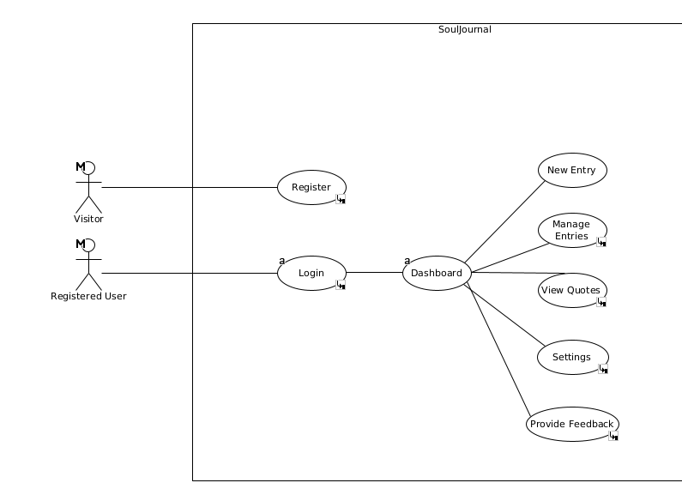Figure 1.1: Top-Level Use-Case Diagram

1. **Register**

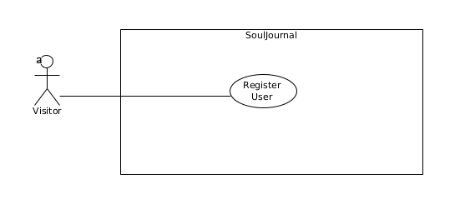Figure 2.1: Register User

|  |  |
| --- | --- |
| **Name** | **Register Customer** |
| **Description** | A non-registered user registers with the system |
| **Priority** | This is a **high** priority requirement. |
| **Scope** | This allows new users to create an account and access the full functionality of the **SoulJournal** application. |
| **Precondition** | The user is not registered with the system. |
| **Flow Description** | |
| **Activation** | This use case starts when an unregistered visitor attempts to create a new account. |
| **Main Flow** | * The user selects the option register. * The system displays the registration form. * The user enters their personal information(first name, last name, email, password). * The user submits the registration form. * The system validates the provided information. * The system creates a new user account. * The system displays the Login page |
| **Alternate Flow** | |
| **Title** | **Description** |
| **The user cancels the registration process** | A1.1. The user cancels the registration process.  A1.2. The use case terminates |
| **Exceptional Flow** | |
| **Title** | **Description** |
| **The provided information (email/password) is invalid** | E1.1. The system displays an error message. (**Title**)  E1.2. The user is prompted to correct the information.  E1.3. The use case continues from main flow 3. |
| **Post-Condition (For Successful Main Flow)** | |
| **Title** | **Description** |
| **Termination** | The system displays registration is successful and the user is given the option to go to the Login section in the SoulJournal application |

1. **Login**

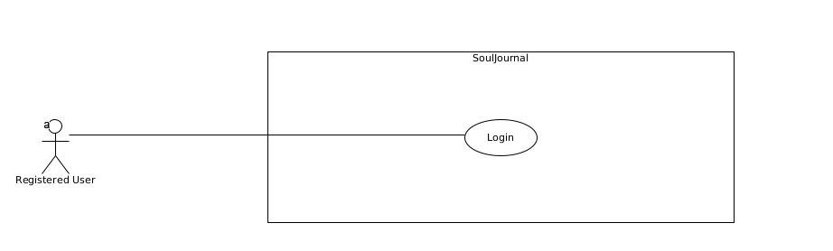Figure 3.1: Login

|  |  |
| --- | --- |
| **Name** | **Login User** |
| **Description** | A registered user logs in the web application |
| **Priority** | This is a **high** priority requirement. |
| **Scope** | This use case describes the process of a registered user authenticating themselves by providing their credentials to gain access to the SoulJournal application. |
| **Precondition** | The user has a registered account. |
| **Flow Description** | |
| **Activation** | This use case starts when a registered user attempts to log in to the application. |
| **Main Flow** | * The system displays the login form. * The user enters their information (email, password). * The user submits the login form. * The system validates the provided information. * The system logs the user into their dashboard |
| **Alternate Flow** | |
| **Title** | **Description** |
| **N/A** | N/A |
| **Exceptional Flow** | |
| **Title** | **Description** |
| **The provided information (email/password) is invalid** | E1.1. The system displays an error message.(**Title**)  E1.2. The user is prompted to enter the correct information.  E1.3. The use case continues from main flow 2. |
| **Post-Condition (For Successful Main Flow)** | |
| **Title** | **Description** |
| **Termination** | The user is logged in to the SoulJournal application dashboard. |

1. **New Entry**

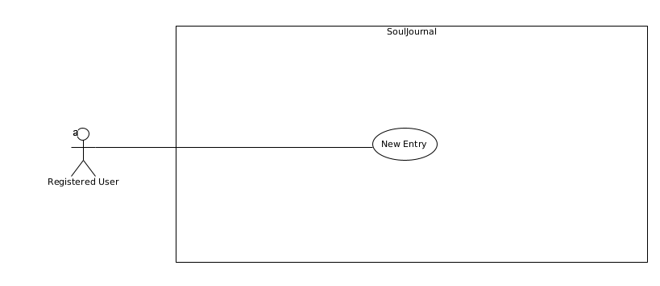Figure 4.1.: New Entry

|  |  |
| --- | --- |
| **Name** | **New Entry** |
| **Main Flow** | * The user selects the “New entry” action. * The system displays a new, blank journal entry form. * The user fills out the form and submits it. * The system saves the new journal entry. * The system updates the database to include the new entry. |
| **Alternate Flow** | |
| **User Cancels Creation** | A1.1. The user cancels the action.  A1.2. The system discards any input.  A1.3. The use case terminates. |
| **Exceptional Flow** | |
| **Title** | **Description** |
| **Error Saving Entry** | E1.1. The system encounters an error saving the entry.  E1.2. The system displays an error message. (**Title**)  E1.3. The user is prompted to try again or cancel.  E1.4. If the user retries, the use case continues at step 3 of the main flow.  E1.5. If the user cancels, the system discards any input and the use case terminates. |

1. **Journal Entries**

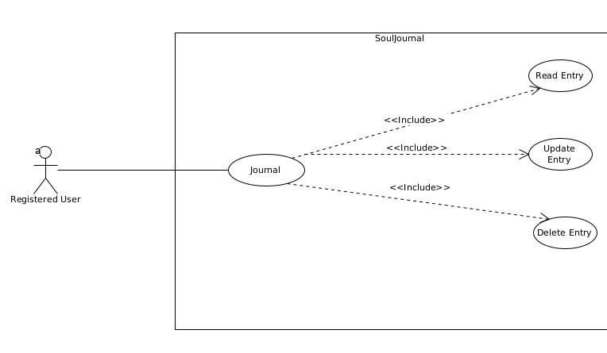Figure 5.1: Journal Entries

|  |  |
| --- | --- |
| **Name** | **Manage Entries** |
| **Description** | A registered user can **R.U.D.** (Read, Update or Delete) their journal entries. |
| **Priority** | This is a **high** priority requirement. |
| **Scope** | This use case enables registered users to **R.U.D. (**Read, Update or Delete)their personal journal entries within the **SoulJournal** application. |
| **Precondition** | The user is logged in to the SoulJournal application |
| **Flow Description** | |
| **Activation** | This use case starts when a logged-in user wants to manage their journal entries. |
| **Main Flow** | * The system displays the user’s journal entries. * The user selects an action (read, update, or delete). * The system executes the selected action on the journal entry. * The system updates the display of journal entries. |

**Individual Flow Descriptions for Journal Entries**

**Read Entry**

|  |  |
| --- | --- |
| **Name** | **Read Entry** |
| **Main Flow** | 1. The user selects the “Read” action. 2. The system displays the selected journal entry in read-only mode. |
| **Alternate Flow** | |
| **User Exits Read Mode** | A1.1. The user exits the read mode.  A1.2. The use case terminates. |
| **Exceptional Flow** | |
| **Title** | **Description** |
| **Error Loading Entry** | E1.1. The system encounters an error loading the entry.  E1.2. The system displays an error message. **(****Title)**  E1.3. The user is prompted to try again or cancel.  E1.4. If the user retries, the use case continues at step 2 of the main flow.  E1.5. If the user cancels, the use case terminates. |

**Update Entry**

|  |  |
| --- | --- |
| **Name** | **Update Entry** |
| **Main Flow** | * The user selects the “Edit” action. * The system displays the selected journal entry in edit mode. * The user modifies the entry and submits the changes. * The system saves the updated entry. * The system updates the display to reflect the changes. |
| **Alternate Flow** | |
| **User Cancels Creation** | A1.1. The user cancels the action.  A1.2. The system discards any changes.  A1.3. The use case terminates. |
| **Exceptional Flow** | |
| **Title** | **Description** |
| **Error Saving Entry** | E1.1. The system encounters an error saving the updated entry.  E1.2. The system displays an error message. **(****Title)**  E1.3. The user is prompted to try again or cancel.  E1.4. If the user retries, the use case continues at step 3 of the main flow.  E1.5. If the user cancels, the system discards any changes and the use case terminates. |

**Delete Entry**

|  |  |
| --- | --- |
| **Name** | **Delete Entry** |
| **Main Flow** | * The user selects the “Delete” action. * The system prompts the user to confirm the deletion. * The user confirms the deletion. * The system deletes the journal entry. * The system updates the journal entries. |
| **Alternate Flow** | |
| **User Cancels Deletion** | A1.1. The user cancels the action.  A1.2. The use case terminates. |
| **Exceptional Flow** | |
| **Title** | **Description** |
| **Error Deleting Entry** | E1.1. The system encounters an error deleting the entry.  E1.2. The system displays an error message. **(****Title)**  E1.3. The user is prompted to try again or cancel.  E1.4. If the user retries, the use case continues at step 3 of the main flow.  E1.5. If the user cancels, the use case terminates. |

1. **Quotes**

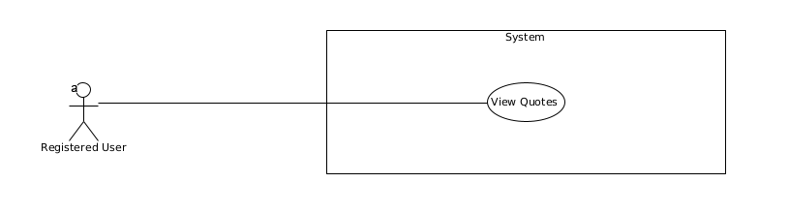

|  |  |
| --- | --- |
| **Name** | **Quotes** |
| **Description** | This allows registered users to view inspirational quotes fetched from the Quotable API. |
| **Priority** | This is a **medium** priority requirement. |
| **Scope** | This use case describes the process of a registered user accessing the Quotes section. |
| **Precondition** | The user is logged in to the SoulJournal application |
| **Flow Description** | |
| **Activation** | This use case starts when a logged-in user wants to view inspirational quotes. |
| **Main Flow** | * The system fetches quotes from the Quotable API. * The system displays the fetched quotes. * The user views the quotes. * The user can select the next quotes. * The user can select the previous quotes. |
| **Alternate Flow** | |
| **Title** | **Description** |
| **The user searches for quotes based on specific topics** | A1.1. The system displays the filtered or searched quotes.  A1.2. The use case continues at step 3 of the main flow. |
| **Exceptional Flow** | |
| **Title** | **Description** |
| **There is an error fetching quotes from the ZenQuotes API** | E1.1. The system displays an error message. **(****“There is an error displaying the quotes”)**  E1.2. The user is prompted to try again.  E1.3. The use case continues at step 1 of the main flow. |
| **Post-Condition (For Successful Main Flow)** | |
| **Title** | **Description** |
| **Termination** | The user has viewed the quotes. |
|  |  |

1. **Provide Feedback**

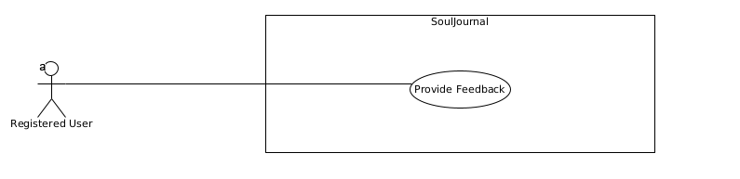Figure 7.1: Provide Feedback

|  |  |
| --- | --- |
| **Name** | **Provide Feedback** |
| **Description** | This use case describes the process of an user providing feedback, suggestions, or reporting issues about the SoulJournal application. |
| **Priority** | This is a **low** priority requirement. |
| **Scope** | This use case allows registered users to submit feedback, suggestions, or report issues regarding the SoulJournal application. |
| **Precondition** | The user is logged in to the SoulJournal application |
| **Flow Description** | |
| **Activation** | This use case starts when a logged user wants to provide feedback, suggestions, or report an issue |
| **Main Flow** | * The system displays the feedback form. * The user enters their feedback, suggestions, or issue details, followed by the amount of stars given. * The user submits the feedback or issue report. * The system displays a confirmation message |
| **Alternate Flow** | |
| **Title** | **Description** |
| **The user cancels the feedback submission** | A1.1. The system discards any entered information  A1.2. The use case terminates. |
| **Exceptional Flow** | |
| **Title** | **Description** |
| **There is an error processing the feedback or issue report.** | E1.1. The system displays an error message. **(****Title)**  E1.2. The user is prompted to try again.  E1.3. The use case continues at step 2 of the main flow. |
| **Post-Condition (For Successful Main Flow)** | |
| **Title** | **Description** |
| **Termination** | The user’s feedback, suggestions, or issue report has been submitted and processed by the system. |

1. **Settings**

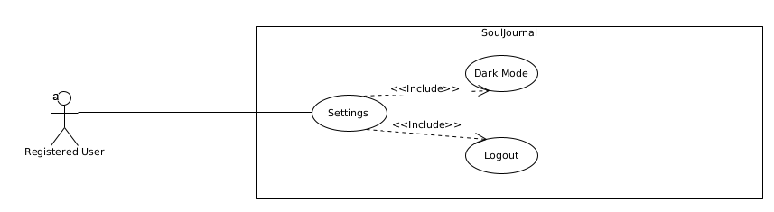Figure 8.1: Settings

|  |  |
| --- | --- |
| **Name** | **Settings (User Interface)** |
| **Description** | A registered user can access the settings of the SoulJournal application, such as themes and options |
| **Priority** | This is a **medium** priority requirement. |
| **Scope** | This use case describes the process of a registered user accessing the Settings option in the dashboard. |
| **Precondition** | The user is logged in to the SoulJournal application |
| **Flow Description** | |
| **Activation** | This use case starts when a logged-in user wants to customize the application's user interface or use another option. |
| **Main Flow** | * The system displays the Settings options, including “Logout” and “Dark Mode”. * The user selects the desired option. * The user applies the changes. * The system applies the user’s choice. |
| **Alternate Flow** | |
| **Title** | **Description** |
| **N/A** | N/A |
| **Exceptional Flow** | |
| **Title** | **Description** |
| **There is an error when applying the settings.** | E1.1. The system displays an error message. **(****Title)**  E1.2. The user is prompted to try again or cancel the changes.  E1.3. The use case continues at step 2 of the main flow. |
| **Post-Condition (For Successful Main Flow)** | |
| **Title** | **Description** |
| **Termination** | The system updates, taking into consideration the decision. |

### Data requirements

The SoulJournal application handles various types of data to provide a personalized journaling experience for users. Key data elements include user credentials(email and password) for regisdtration and authentication, user preferences such as theme settings(Dark Mode), and journal entries. Additionally, the system manages feedback data to improve user experience and application functionality.

Data is transmitted between the frontend and backend using HTTP requests, typically in a RESTful API format. User actions on the frontend trigger these requests, sending data in a JSON format to the backend server. The server processes the requests, performs necessary operations such as database interactions, and sends back responses to the frontend.

### User requirements

This section outlines the objectives and requirements for the SoulJournal web application from the customer’s perspective, detailing what users want and need from the system.

**Objectives and Requirements**

1. **Ease of Use:**

* Users want an easy-to-navigate interface that will require minimal training and waiting time
* Ability to customize their journaling experience.

1. **Accesibility:**

* Users want the ability to access their journals across various devices including desktops, laptops, and smartphones.

1. **Privacy and Security:**

* Users require their journal entries to be securely stored and protected from unauthorized access.

1. **Functionality:**

* Users want efficient ways to search categorize, and tag journal entries for easy retrieval
* Users want a mini audio player that would be accessible in the creation of the entry.

1. **Inspiration and Motivation**

* Users want something that will give them the motivation to write. Users will receive daily inspirational quotes from the Quotable API to motivate and inspire their journaling experience. This feature provides a fresh quote on a click of a button, and it also has the ability to retrieve previous quotes.

When the primary focus is on user needs, certain technical requirements must also be met to ensure the objectives are achieved:

* **Web Browser**: The SoulJournal web application will be accessible through a modern web browser, ensuring cross-platform compatibility.
* I**nternet Connection**: Users wil require an active internet connection to access the **SoulJournal** application, as it will be hosted on a remote server.
* **Computing Device:** users can access the SoulJournal application from various computed devices, such as desktop computers, laptops, or smart-phones

### Environmental requirements

The SoulJournal application operates under the following environmental conditions:

1. **Server Environment:**

* **Operating System:** The server that will host the backend is a Linux-based(LUbuntu) one.
* **Database:** MongoDB is used for storing journal entries, user data, and feedback.
* **Runtime Environment**: Node.js for executing server-side JavaScript code.
* **Web Server:** Express.js for handling HTTP requests and serving the application.

1. **Client Environment:**

* **Web Browsers:** The application is designed to be compatible with modern browser such as Google Chrome, Mozilla Firefox, Microsoft Edge, and Safari.
* **Operating Systems:** The application should function correctly on major operating systems, including Windows, macOS, and Linux.

1. **Development Environment:**

* **IDE:** Visual Studio Code is used for development due to its robust support for JavaScript and Node.js
* **Version Control**: Git for source code management and version control.
* **Package Management:** npm for managing project dependencies.

1. **Hardware Requirements:**

* **Server Hardware:** A running server with a bare minimum of resources (512MB RAM for the memory, 2GB for the storage should be enough).
* **Client Hardware:** Standard consumer-grade hardware(PCs, laptops, tablets) with sufficient processing power and memory to run modern web browsers.

### Usability requirements

The SoulJournal web application must meet the following usability criteria to ensure a positive user experience:

1. **Ease of Use:**

* The user interface should be intuitive and easy to navigate, allowing users to quickly access and use the application’s features without extensive training or documentation.
* Common acctions such as creating a new journal entry, logging in, and accessing settings should be easily accessible from the main dashboard.

1. **Consistency:**

* The application sdhould maintain a consistent look and feel across all pages and components. This includes consistent use of colors, fonts, and button styles.
* Error messages and notifications should follow a consistent format and be displayed in a predictable location.

1. **Performance:**

* The application should load quickly and respond promptly to user interactions. Page load times should be minimized, and actions such as saving a journal entry or updating settings should be processed without noticeable delay.
* The backend server should handle requests efficiently, ensuring a smooth user experience even under high load.

1. **Customization**

* Users should be able to customize their experience, such as toggling dark mode
* Customization options should be easily accessible from the settings page.

1. **Feedback**

* The application sdhould provide immediate feedback for user actions. For example, when a user submits a journal entry, a confirmation message should be displayed.
* Error messages should be clear and informative, guiding users on how to correct the issue.

## Design and Architecture

The system architecture of SoulJournal is designed to be modular and scalable, ensuring smooth interaction between various components. The architecture will consist of three main layers:

* **Front-End**
* **Back-End**
* **Database**

**Components:**

1. **Front-End (Client-Side)**

* **Technologies:** React.js, HTML, CSS, Bootstrap
* **Role:** Provides the user interface for creating entries, managing entries, quote display, and feedback.
* **Interaction:** Sends user inputs and requests to the backend via HTTP

1. **Back-End (Server-Side)**

* **Technologies:** Node.js, Express.js
* **Role:** Handles authentication, user requests, and manages interactions with the database and external APIs.
* **Interaction:**
  + Receives data from the frontend.
  + Processes and validates the data.
  + Communicates with the database to store and retrieve data.
  + Integrates with the Quotable API to fetch and deliver quotes.
  + Sends responses back to the frontend with the necessary data.

1. **Database**

* **Technologies:** MongoDB
* **Role:** Stores user data, journal entries and feedback submissions.
* **Interaction:**
  + Receives read/write requests from the backend.
  + Returns the requested data to the backend for further processing or direct user interaction.

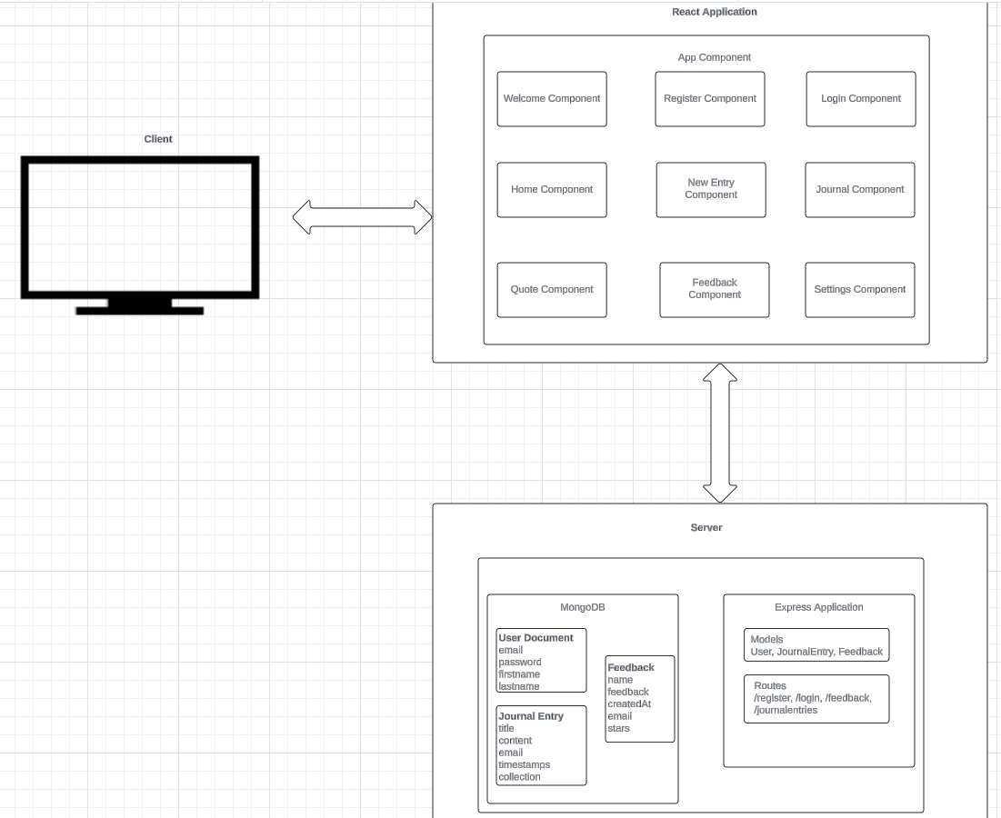Figure 2.2.1: Architecture Design

1. **Client (React)**

* **Components:**
  + **WelcomePage.js:** Serves as the landing page when the user enters the application. It includes the **Register** component and **Login** component as buttons.
  + **Register.js:** Handles user registration.
  + **Login.js:** Handles user authentication. Upon submission, it sends the credentials to the backend to verify and log the user in.
  + **Quotes.js:** This component displays quotes. It fetches quotes from an API.
  + **Feedback.js:** This component handles feedback submission. It includes a form where users can enter their comments or suggestions and submit them to the backend.
  + **NewEntry.js:** This component is used for creating new journal entries. It includes a form where users can write their thoughts or experiences, rate them according to their mood, and save them to the journal.
  + **Journal.js**: This component displays all the journal entries for the user. It fetches the entries from the backend and renders them for the user to view. The user can update the entries, and also delete them, by choice.
  + **Home.js**: This component serves as the main dashboard/homepage of the application. It provides navigation to other parts of the application.
  + **RadioPlayer.js:** This component is a radio player interface. It allows users to listen to live radio streams, depending on the type of music the user wants to listen.
  + **Settings.js:** This component allows users to manage their account settings. It includes options to change the password, logout or change the theme of the application.
* **State Maangement:** Uses React’s useState and useEffect hooks.
* **Styling:** Uses Bootstrap for styling.

1. **Server (Node.js)**

* **Endpoints:**
  + /auth/register*:* Handles user registration.
  + /auth/login: Handles user authentication
  + journal/new_entry: Handles new entry creation.
  + journal/entries: Handles R.U.D requests(Read, Update, Delete).
  + /feedback/submit-feedback: Handles feedback submissions.
* Middleware: Uses Express.js for routing and middleware, Cors for middleware.

1. **Database (MongoDB)**

* **Collections:**
  + users: Stores user information.
  + entries: Stores journal entries.
  + feedback: Stores user feedback.

**Main Algorithms**

1. **User Registration**

The user registration process involves validating the email format and ensuring the password meets a minimum length requirement.

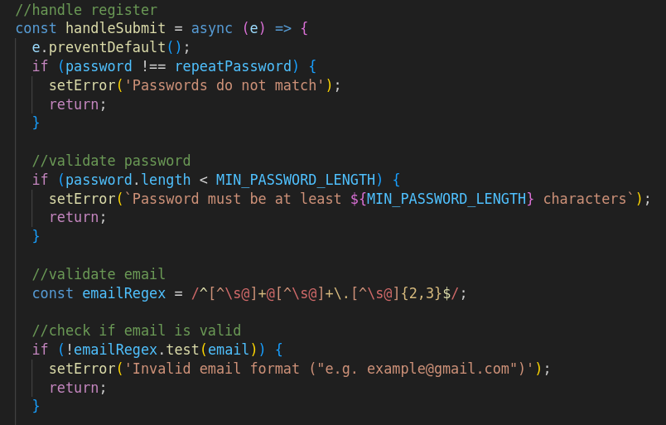Figure 1.1: User Registration Algorithm

**Algorithm:**

* 1. Validate email format using a regular expression.
  2. Check if the password meets the minimum length requirement.
  3. Check if the **password** matches with the **repeatPassword**
  4. If valid, send a POST request to the server to register the user.

1. **Star Rating System**

The star rating system allows users to rate from 1 to 5 stars. The rating is updated based on user interaction (click and hover).

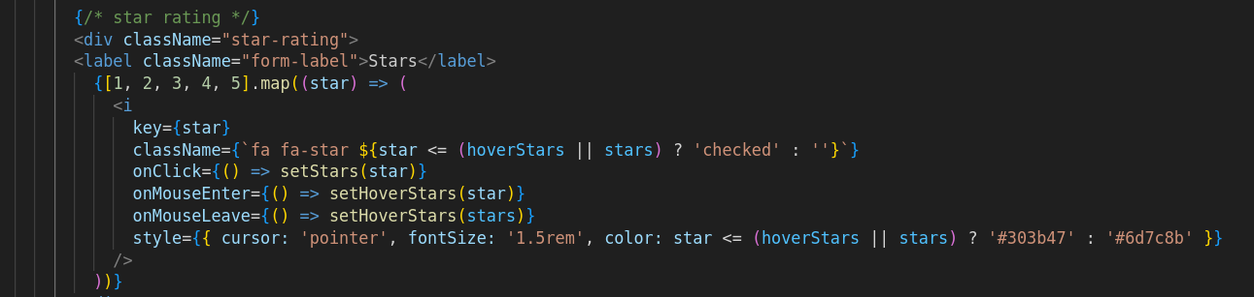Figure 2.1: Star Rating System

**Algorithm:**

* 1. Initialize state variables for **stars** and **hoverStars**.
  2. On star click, update the **stars** state.
  3. On star hover, update the **hoverStars** state.
  4. On mouse leave, reset **hoverStars** to **stars**.

1. **Date Formatting Algorithm**

An algorithm that converts a date string into a **Date** object, extracts year, month, day, and formats it as DD-MM-YYYY.

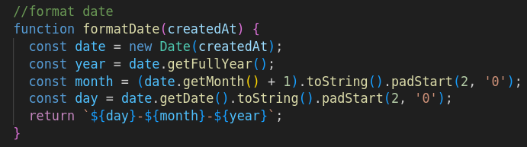

**Algorithm:**

* 1. Define a function formatDate that takes a parameter createdAt.
  2. Inside the function, create a new Date object using the createdAt parameter.
  3. Extract the year, month, and day using getFullYear(), getMonth() + 1, getDate() and pad the last two get methods to only two digits.
  4. Combine the day, month, and year into a string formatted as DD-MM-YYYY.
  5. Return the formatted date string from the function.

1. **Entries per Page Logic Algorithm**

An algorithm that dynamically adjusts the number of journal entries displayed per page based on the window width.

**Algorithm:**

1. The **updateEntriesPerPage** function determines the number of entries to display per page based on the current window width. It also uses **window.innerWidth** to get the current width of the window.
2. Set the number of entries per page based on window width.
3. The **updateEntriesPerPage** function is called immediately to set the initial number of entries per page based on the current window width.
4. An event listener is added to the **resize** event of the window. Whenever the window is resized, the **updateEntriesPerPage** function is called to adjust the number of entries per page dynamically

Describe the design, system architecture and components used. Describe the main algorithms used in the project. (Note: use standard mathematical notations if applicable).

An architecture diagram may be useful. In case of a distributed system, it may be useful to describe functions and/or data structures in each component separately.

## Implementation

Describe the main classes/functions used in the code. Consider to show and explain interesting code snippets where appropriate.

## Testing

Describe any testing tools, test plans and test specifications used in the project

## Graphical User Interface (GUI) Layout

Provide screenshots of key screens and explain.

## Customer testing

Provide evidence for and results of customer testing. This may include ratings or quotes from the customer.

## Evaluation

How was the system evaluated and what are the results? In many cases this will include usage data and user feedback. It may also include performance evaluations, scalability, correctness, etc. depending on the focus of the project.

Quantitative results may be reported in tables or figures. Note that tables have their caption above the table and need to be cross referenced in the text (see Table 1). In many cases, tables are better to read if you skip the vertical lines.

|  |  |  |  |  |  |
| --- | --- | --- | --- | --- | --- |
|  | **Nwithout** | **Nwith** | **Std.-Deviationwith** | **Std.-Deviationwithout** | **p** |
| Records | 100 | 200 | 2.54 | 3.97 | .002 |
| Data (GB) | 100 | 200 | 2.54 | 3.97 | .002 |
| Speed | 100 | 200 | 2.54 | 3.97 | .002 |

Table 1: Performance with and without caching

Figures have their caption below the figure as shown in Figure 3Error: Reference source not found Make sure that if you use colour, the figure is still readable when printed in black & white, e.g., by using additional symbols, patterns, etc.



Figure 3: Learning gain across different experimental groups

# Conclusions

Describe the advantages/disadvantages, opportunities, and limits of the project.

# Further development or research

With more resources, where could the results of this project lead to?

# References

It is recommended that students use the APA, Berkeley, Harvard or other internationally approved style. Here is an example of the APA citation style:

Wilcox, R. V. (1991). Shifting roles and synthetic women in Star Trek: The Next Generation. *Studies in Popular Culture, 13*(2), 53-65.

In the text this article can be cited as “Wilcox (1991)” or “(Wilkox, 1991)”.

References to websites must include the access dates.

The NCI library provides a guide on referencing

<https://libguides.ncirl.ie/referencingandavoidingplagiarism>

# Appendix

## Project Proposal

## Project Plan

## Requirement Specification

## Monthly Journal

## Other Material Used

Any other reference material used in the project for example evaluation surveys, etc.